**S103-**

|  |  |  |
| --- | --- | --- |
| **Calendar** | **General User** | **View Event Calendar** |

**Basic Outline:**

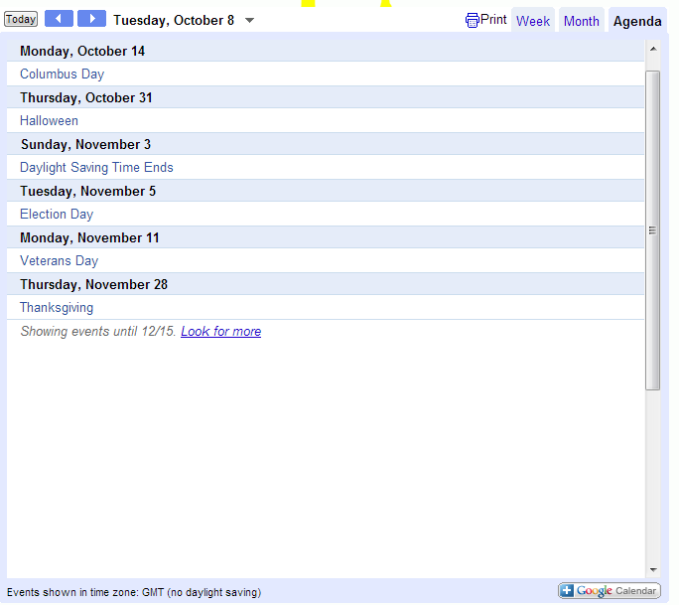

**Additional Information:**

* Calendar is always updated
* Additional links to details view
* Link for printing
* Different viewing options (Week, Month, Agenda)
* Button to add to personal Google Calendar